# Cognitive skill

## Definition

**# Source**: **Chatgpt (GPT-4-turbo) at [7/6/2025]**

**Cognitive skills** are the core mental abilities your brain uses to think, learn, remember, reason, and pay attention. These skills are essential for acquiring knowledge and understanding the world. They are the foundation for all learning processes.

### cognitive skills photo

**# Source**: [Multi sources](https://drive.google.com/drive/folders/1FOdR7JDlg1730P2fa8S6yCAO-7LzU8y8?usp=drive_link): [Cognitive Skills](https://drive.google.com/file/d/1Ha1o7Imr_hKuWdK7_qBFIuLb0UrQBzew/view?usp=drive_link) -> at - (**0:15**)

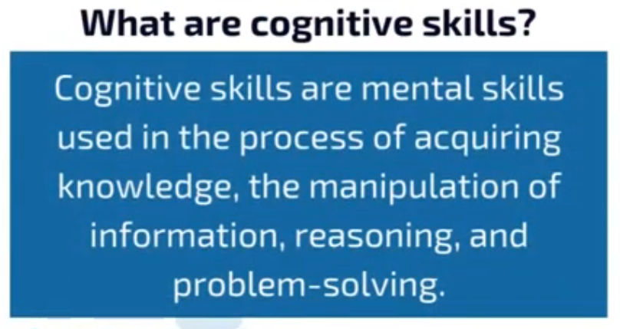

Cognitive skills are mental skills used in the process of acquiring knowledge, the manipulation of information, reasoning, and problem-solving.

### what are core cognitive skills photo

**# Source**: [Multi sources](https://drive.google.com/drive/folders/1FOdR7JDlg1730P2fa8S6yCAO-7LzU8y8?usp=drive_link): [Cognitive Skills](https://drive.google.com/file/d/1Ha1o7Imr_hKuWdK7_qBFIuLb0UrQBzew/view?usp=drive_link) -> at - (**0:23**)

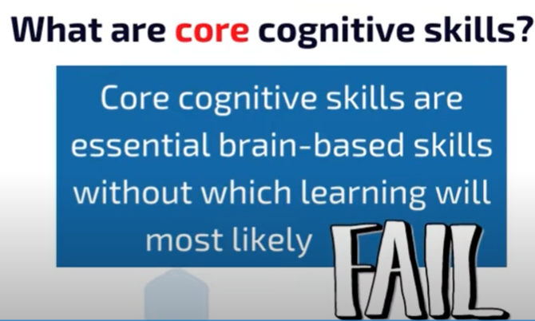

Core cognitive skills are essential brain-based skills without which learning will most likely

## Why Cognitive Skills Matter:

**# Source**: **Chatgpt (GPT-4-turbo) at [7/6/2025]**

Strong cognitive skills help in:

* Academic learning
* Professional tasks
* Daily problem-solving
* Social interactions

### Why do core cognitive skills matter photo

**# Source**: [Multi sources](https://drive.google.com/drive/folders/1FOdR7JDlg1730P2fa8S6yCAO-7LzU8y8?usp=drive_link): [Cognitive Skills](https://drive.google.com/file/d/1Ha1o7Imr_hKuWdK7_qBFIuLb0UrQBzew/view?usp=drive_link) -> at - (**1:09**)

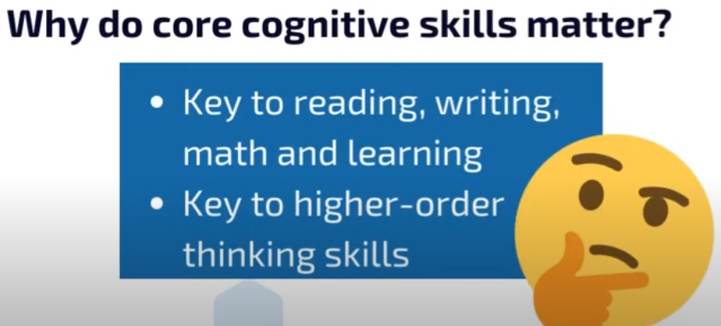

- Key to reading, writing, math and learning

- Key to higher-order thinking skills

## Main Types of Cognitive Skills:

**# Source**: **Chatgpt (GPT-4-turbo) at [7/6/2025]**

1. **Attention** – The ability to concentrate and focus on specific tasks or information.
2. **Memory** –  
   * *Short-term memory*: Holding small amounts of information for a brief time.
   * *Long-term memory*: Storing and recalling information over long periods.
3. **Processing speed** – How quickly your brain can take in and respond to information.
4. **Logic and reasoning** – The ability to solve problems and make decisions based on information.
5. **Auditory processing** – Understanding and interpreting sounds and language.
6. **Visual processing** – Understanding and interpreting visual information, like patterns and images.
7. **Executive function** – High-level skills like planning, organizing, managing time, and self-control.

### 1-Attention

#### Definition

**# Source**: [Multi sources](https://drive.google.com/drive/folders/1FOdR7JDlg1730P2fa8S6yCAO-7LzU8y8?usp=drive_link): [What Are Cognitive Skills 2](https://drive.google.com/file/d/114s4T-6qTzk-_4RrxezAFQvTz0lV6ujY/view?usp=drive_link) -> at - (**Focus & Attention**)

Attention is the brain’s ability to zero in on specific information or tasks while filtering out distractions. It’s [a vital skill](https://pmc.ncbi.nlm.nih.gov/articles/PMC2865224/) for productivity and learning, acting as the gateway through which all information passes.

#### Types of attention include:

**# Source**: [Multi sources](https://drive.google.com/drive/folders/1FOdR7JDlg1730P2fa8S6yCAO-7LzU8y8?usp=drive_link): [What Are Cognitive Skills 2](https://drive.google.com/file/d/114s4T-6qTzk-_4RrxezAFQvTz0lV6ujY/view?usp=drive_link) -> at - (**Types of attention include**)

* **Phasic Alert (Arousal)**: The ability to respond quickly to sudden environmental changes. For example, stopping what you’re doing after hearing a thunderclap.
* **Sustained Attention (Focus)**: Staying focused on a single task for an extended period, like studying or working on a long project.
* **Selective Attention**: Filtering out distractions to concentrate on what’s important, such as listening to a friend in a noisy restaurant.
* **Divided Attention**: Splitting focus between multiple tasks, like cooking dinner while following a podcast.
* **Alternating Attention**: Switching focus between tasks, like reading an email and then taking a phone call.

#### Attention photo

**# Source**: [Multi sources](https://drive.google.com/drive/folders/1FOdR7JDlg1730P2fa8S6yCAO-7LzU8y8?usp=drive_link): [Cognitive Skills](https://drive.google.com/file/d/1Ha1o7Imr_hKuWdK7_qBFIuLb0UrQBzew/view?usp=drive_link) -> at - (**0:44**)

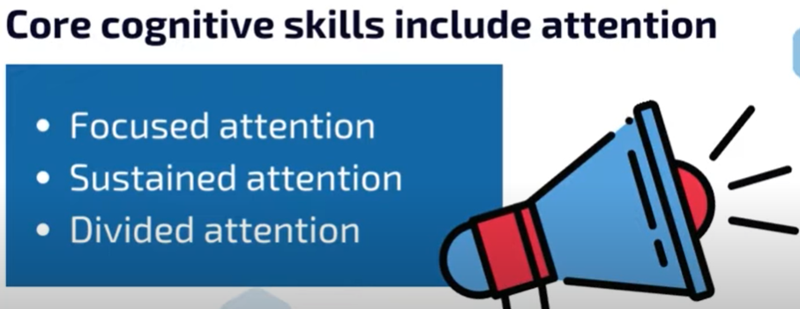

### 2-Memory

#### Definition

**# Source**: [Multi sources](https://drive.google.com/drive/folders/1FOdR7JDlg1730P2fa8S6yCAO-7LzU8y8?usp=drive_link): [What Are Cognitive Skills 2](https://drive.google.com/file/d/114s4T-6qTzk-_4RrxezAFQvTz0lV6ujY/view?usp=drive_link) -> at - (**Memory & Recognition**)

#### Memory and recognition serve as the building blocks of learning and problem-solving. They enable us to store, retrieve, recognize, and use information effectively for immediate tasks and long-term growth.

#### 

#### 

#### Memory photo

**# Source**: [Multi sources](https://drive.google.com/drive/folders/1FOdR7JDlg1730P2fa8S6yCAO-7LzU8y8?usp=drive_link): [Cognitive Skills](https://drive.google.com/file/d/1Ha1o7Imr_hKuWdK7_qBFIuLb0UrQBzew/view?usp=drive_link) -> at - (**0:55**)

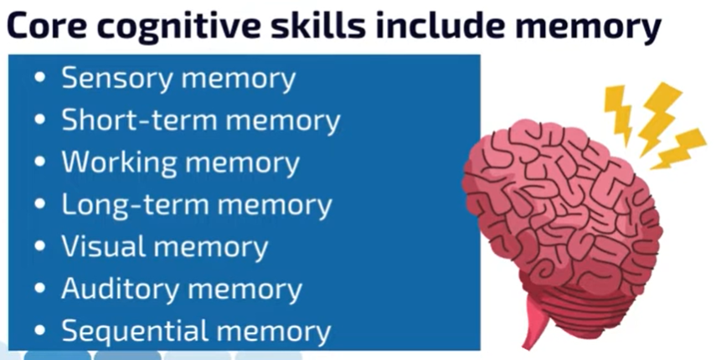

#### Memory Types

Memory can be classified in **two main ways**:

##### 🔹 1. Memory by Size (Duration)

**# Source**: **Chatgpt (GPT-4-turbo) at [7/6/2025]**

This classification is based on **how long** the memory lasts.

###### ▪️ Sensory Memory

**# Source**: **Chatgpt (GPT-4-turbo) at [7/6/2025]**

* **Duration:** A few milliseconds to 1–2 seconds
* **Function:** Briefly holds sensory information (like sights and sounds)
* **Types:**
  + *Iconic memory* – Visual
  + *Echoic memory* – Auditory
  + *Haptic memory* – Touch

###### ▪️ Short-Term Memory (STM)

**# Source**: **Chatgpt (GPT-4-turbo) at [7/6/2025]**

* **Duration:** About 15–30 seconds
* **Capacity:** 7 ± 2 items
* **Function:** Temporarily holds information for immediate use
* **Example:** Remembering a phone number long enough to dial it

###### ▪️ Working Memory

**# Source**: **Chatgpt (GPT-4-turbo) at [7/6/2025]**

* A refined form of STM; used to **manipulate and use** info actively.
* Example: Solving a math problem in your head

###### ▪️ Long-Term Memory (LTM)

**# Source**: **Chatgpt (GPT-4-turbo) at [7/6/2025]**

* **Duration:** From minutes to a lifetime
* **Capacity:** Unlimited (in theory)
* **Function:** Stores information over long periods
* **Example:** Your name, the capital of France, your childhood memories

##### 🔹 2. Memory by Type (Function/Content)

**# Source**: **Chatgpt (GPT-4-turbo) at [7/6/2025]**

This classification is based on **what kind** of information is stored.

###### ▪️ Explicit (Declarative) Memory

**# Source**: **Chatgpt (GPT-4-turbo) at [7/6/2025]**

* **Conscious** recall
* **Types:**
  + **Episodic memory** – Personal experiences/events (e.g., birthday party)
  + **Semantic memory** – Facts and knowledge (e.g., Paris is the capital of France)

###### ▪️ Implicit (Non-declarative) Memory

**# Source**: **Chatgpt (GPT-4-turbo) at [7/6/2025]**

* **Unconscious** recall
* **Types:**
  + **Procedural memory** – Skills and actions (e.g., riding a bike)
  + **Priming** – Exposure to one stimulus influences response to another
  + **Conditioning** – Learned associations (e.g., Pavlov's dogs)

### 3-Logic & Reasoning

#### Definition

**# Source**: [Multi sources](https://drive.google.com/drive/folders/1FOdR7JDlg1730P2fa8S6yCAO-7LzU8y8?usp=drive_link): [What Are Cognitive Skills 2](https://drive.google.com/file/d/114s4T-6qTzk-_4RrxezAFQvTz0lV6ujY/view?usp=drive_link) -> at - (**Logic and Reasoning**)

Logic and reasoning help us think critically, solve problems, and make informed decisions by analyzing information, spotting patterns, and drawing conclusions.

#### Logical reasoning photo

**# Source**: [Multi sources](https://drive.google.com/drive/folders/1FOdR7JDlg1730P2fa8S6yCAO-7LzU8y8?usp=drive_link): [Cognitive Skills](https://drive.google.com/file/d/1Ha1o7Imr_hKuWdK7_qBFIuLb0UrQBzew/view?usp=drive_link) -> at - (**1:00**)

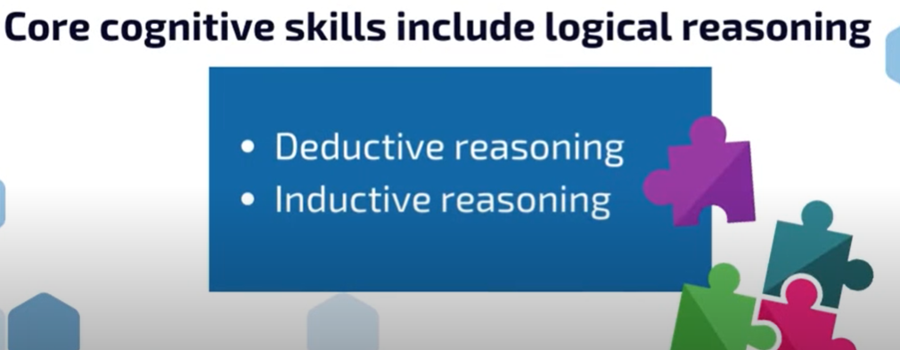

#### Logic & Reasoning Types

**# Source**: [Multi sources](https://drive.google.com/drive/folders/1FOdR7JDlg1730P2fa8S6yCAO-7LzU8y8?usp=drive_link): [What Are Cognitive Skills 2](https://drive.google.com/file/d/114s4T-6qTzk-_4RrxezAFQvTz0lV6ujY/view?usp=drive_link) -> at - (**Logic and Reasoning**)

* **Deductive Reasoning**: Using general rules to solve specific problems, like choosing the best route home based on traffic.
* **Inductive Reasoning**: Identifying patterns to predict outcomes, such as forecasting market trends from sales data.
* **Problem-Solving**: Finding and applying solutions to challenges, like fixing a software issue at work.

We need strong logic and reasoning skills to [navigate complex situations](https://openurl.ebsco.com/EPDB%3Agcd%3A11%3A9073803/detailv2?sid=ebsco%3Aplink%3Ascholar&id=ebsco%3Agcd%3A179594258&crl=c&link_origin=scholar.google.co.il) and make sound decisions.

### 4-Processing

#### Definition

**# Source**: **Chatgpt (GPT-4-turbo) at [7/6/2025]**

**Processing** refers to the **mental activities your brain uses to take in, interpret, organize, store, and respond to information.** It's a key part of how we think, learn, and make decisions.

#### Processing photo

**# Source**: [Multi sources](https://drive.google.com/drive/folders/1FOdR7JDlg1730P2fa8S6yCAO-7LzU8y8?usp=drive_link): [Cognitive Skills](https://drive.google.com/file/d/1Ha1o7Imr_hKuWdK7_qBFIuLb0UrQBzew/view?usp=drive_link) -> at - (**0:35**)

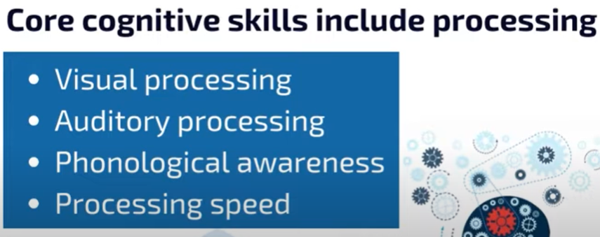

#### Processing Types

##### 1. Information Processing

**# Source**: **Chatgpt (GPT-4-turbo) at [7/6/2025]**

* Describes how the brain acts like a computer:  
  + **Input** (gathering information through senses)
  + **Processing** (thinking, comparing, analyzing)
  + **Output** (responses, actions, thoughts)

##### 2. Processing Speed

**# Source**: **Chatgpt (GPT-4-turbo) at [7/6/2025]**

* **Definition:** How quickly your brain can take in, understand, and respond to information.
* **Example:** Solving a math problem quickly or reacting to a question fast.

##### 3. Auditory Processing

**# Source**: **Chatgpt (GPT-4-turbo) at [7/6/2025]**

* **Definition:** How well your brain understands sounds and spoken language.
* **Example:** Following verbal instructions or distinguishing similar-sounding words.

##### 4. Visual Processing

**# Source**: **Chatgpt (GPT-4-turbo) at [7/6/2025]**

* **Definition:** How well your brain interprets visual information (images, shapes, patterns).
* **Example:** Reading, recognizing faces, or solving puzzles.

##### 5. Deep vs. Shallow Processing

**# Source**: **Chatgpt (GPT-4-turbo) at [7/6/2025]**

* **Deep Processing:** Involves understanding meaning (leads to better memory).
* **Shallow Processing:** Focuses on surface details (like appearance or sound).

#### 🧠 Why It Matters:

**# Source**: **Chatgpt (GPT-4-turbo) at [7/6/2025]**

Strong processing abilities are **essential for learning, memory, attention, and decision-making.** Weak processing skills can lead to difficulties in reading, listening, problem-solving, or academic performance.

## How Do Cognitive Skills Work?

**# Source**: [Multi sources](https://drive.google.com/drive/folders/1FOdR7JDlg1730P2fa8S6yCAO-7LzU8y8?usp=drive_link):  [What Are Cognitive Skill](https://drive.google.com/file/d/1jXRVdRB7KY6EDnAJ_vnkKYhuVjCgTdXK/view?usp=drive_link) -> at - (**Top**)

